Patrice Moracchini
CSD310-308A(2261-DD)
Nov 2, 2025

Visual Paradigm
Module 2.2 assignment
Pr. Sampson

EDR Graphic

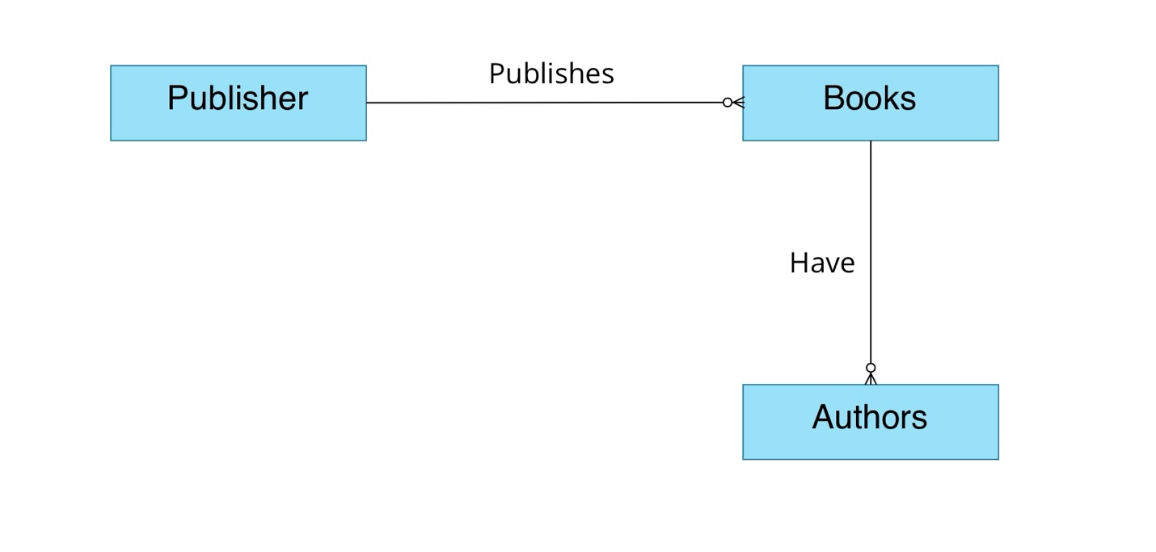

Made with Visual Paradigm

